Don’t Miss the Most Talked-About Booth at NRB
Reserve Your Private 30-Minute Executive Meeting
February 17-20, 2026 | Nashville, TN | Booth #401, Ryman Exhibit Hall
⚡ LIMITED AVAILABILITY: Only 35 Executive Meeting Slots for the Entire Event
Over 2,000 ministry leaders experienced our flagship booth at the NRB 2025 conference.
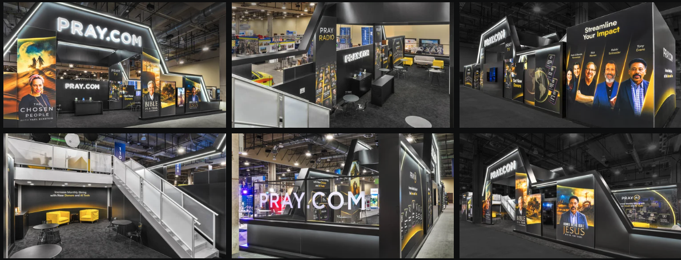

⚡NRB 2026 Will Be Even Bigger
Our booth offers a glimpse into the future of our mission, inviting you to experience the next chapter of faith-filled living
—---------------------------------------—---------------------------------------—---------------------------------------—-----------------------------

Why Pre-Book Your Meeting?
✓ Skip the Lines: Guaranteed meeting time—no 2-hour wait times like we saw last year
✓ Executive Access: Meet directly with our leadership team, not booth staff
✓ Tailored Strategy Session: Custom growth roadmap for your ministry’s specific goals
✓ Exclusive Perks: A special gift and exclusive swag, just for you.

PRAY.COM is reshaping ministry in 2026.

Here’s what you’ll have access to:
SuperFunnel Demo | See how partner ministries achieve 1.5x–2.5x ROI on digital campaigns with proven donor acquisition strategies
Game-Changing Tools. One Booth Visit. | Live walkthrough of AI-powered content tools that 10x your team’s output—turn 1 sermon into 30 days of content
Reach Distribution | How to amplify your message to 20M+ engaged users beyond your current reach
America Prays 250 | Exclusive partnership opportunities with our White House national prayer initiative

Trusted by Ministry Pioneers
(photos)
20M+  Active Users | 500+  Partner Churches | $2.3M  Avg Partner Revenue | 4.7x  Avg Partner ROI

📅 READY TO BOOK YOUR MEETING?
Click here to choose your preferred meeting time: [CALENDAR LINK]
Or reply to this email with your preferred date/time, and we’ll book it manually.
PRAY.COM @ NRB 2026 | Booth #401, Ryman Exhibit Hall| February 17-20, 2026 | Gaylord Opryland, Nashville

